**Symbiosis School, Nasik.**

**Std: X Term I (2020-21)**

**Subject: English Language & Literature - Worksheet – 38**

**Lesson : Poem 10 – The Tale of Custard the Dragon**

**By Ogden Nash**

**About the Author**

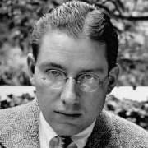

Frederick Ogden Nash was born in Rye, New York, to Edmund Strudwick Nash and Mattie Chenault on August 19, 1902. His father was in the import-export business. Nash grew up in various East Coast communities and also lived in Savannah, Georgia, during his youth. He attended St. George's School in Newport, Rhode Island, and he was accepted to Harvard but dropped out in 1921 after a year.

Nash held a variety of jobs but none for very long. He worked on Wall Street as a bond salesperson, but sold only one bond—to his godmother—and instead spent his afternoons in movie theaters. He was a schoolteacher for a year at St. George's School, and from there he was hired as an advertising copywriter for streetcar signs. In 1925 he was hired in the marketing department of the Doubleday publishing house and did well enough that he moved on to its editorial department as a manuscript reader.

### During the 1930s and 1940s, Nash's poems continued to appear in many magazines and published collections, and he was praised as one of America's greatest humorists Introduction to the lesson

Ogden Nash has written a poem about a little girl Belinda who owns many pets, namely, a black kitten named ink, grey mouse named blink, yellow dog named mustard and a coward dragon named custard. The poet has described every character to be brave except the dragon who is a coward. But the whole situation changes when a pirate attacked Belinda’s house. No one else had the guts to face him, it was the dragon that killed the pirate. All the characters are happy because they are saved by the dragon but quickly change their thoughts and describe themselves to be more powerful had the situation not been so confusing for all of them.

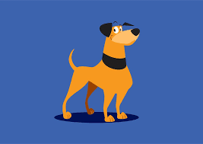 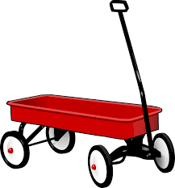 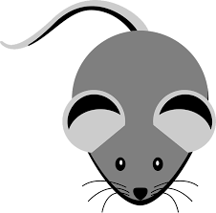

 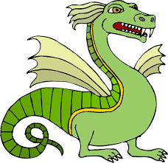 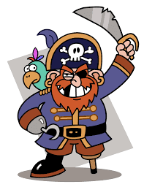

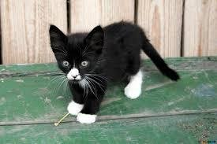

Summary of the poem

The tale of custard the dragon is a ballad. It is a humorous poem about a cowardly dragon named custard. Custard is a pet of Belinda, a little girl who lives in a little white house with her pets. She had a black kitten named ink, a grey mouse named blink, a yellow dog mustard and a cowardly dragon custard. The poet says that all of them are very brave except the dragon. Others were described as brave and are compared with animals like bear, tiger or lion but the dragon is very timid. He always demands a safe place for himself. All the other characters make fun of him. But one night they are surprised by the entry of a pirate in the house. All of them get frightened and start hiding here and there. But to everyone’s surprise, the dragon not only tackles him but also eats him up. As all of them are saved by custard, they thank him. But at the end, they realize that they used to make fun of the dragon because of his being timid. So, all of them suddenly start saying that they are more brave and could have handled the situation in a much better way. Here the poet has tried to say that sometimes a timid person is the actual hero in the toughest situations of life.

**Word Meanings**

Mustard: a yellow coloured flower  
Coward: weakling

Spikes: thin pointed surface  
Scales: Thin bony plates protecting the skin of fish and reptiles.  
Underneath: situated directly below  
Fire place: An outdoor structure of brick, stone or metal for an open fire  
Dagger: A sharp knife

Barrel: drum  
Chased: hunt, follow  
Rage: anger

Tickled: stroke, here it means to tease  
Unmerciful: cruel  
Percival: A knight in King Arthur’s court

Giggled: to laugh  
Weeck: Here it is the sound made by the mouse

Nasty: bad or unpleasant  
Growled: bark  
Pirate: A person who robs ship in the sea  
Winda: it is used for window

Pistol: a handgun  
Cutlass: a short sword with a

curved blade.

Paled: turn yellow due to fear  
Yelp: a short sharp cry  
Trickled: here, run  
Strategically: planned  
Mouseholed:  here it is the hole where the mouse lives.

Snorting: make a sudden explosive sound through one’s nose  
Clashed: fought  
Dungeon: underground prison  
Clatter Clank: sound of hard object falling on each other  
Jangling squirm: sound of hard object falling on each other  
Robin: A bird

Gaped: stared with mouth wide open  
Gulped: swallow  
Grog: a drink  
Flagon: a container made of silver in which drink is stored  
Gobbled: swallowed hurriedly

Embraced: to hug  
Mourned: feel sorrow for the death of someone  
Victim: sufferer  
Glee: delight  
Gyrate: danced

Flustered: upset or confused

**Concept Based Questions**

**Question 1.**

Where did Belinda live and with whom?

**Question 2.**

What did Custard look like?

**Question 3.**

Did Custard match his physical appearance?

**Question 4.**

Describe the bravery of everyone in the house.

**Question 5.**

Was everyone really as brave as they claimed?

**Question 6.**

What did everyone do when the pirate came?

**Question 7.**

How did Custard face the pirate?